Disease Prediction System

Web Link:
https://disease-prediction-system-suyash.streamlit.app/

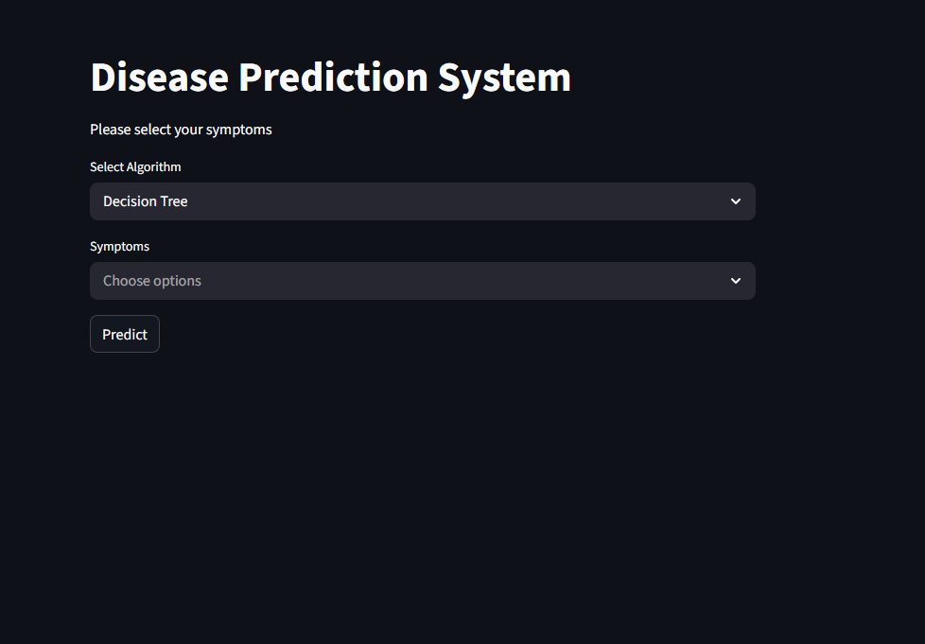
Images of the system: there are two type of machine learning Modal for comparison Decision tree and other is Random forest
1.1.

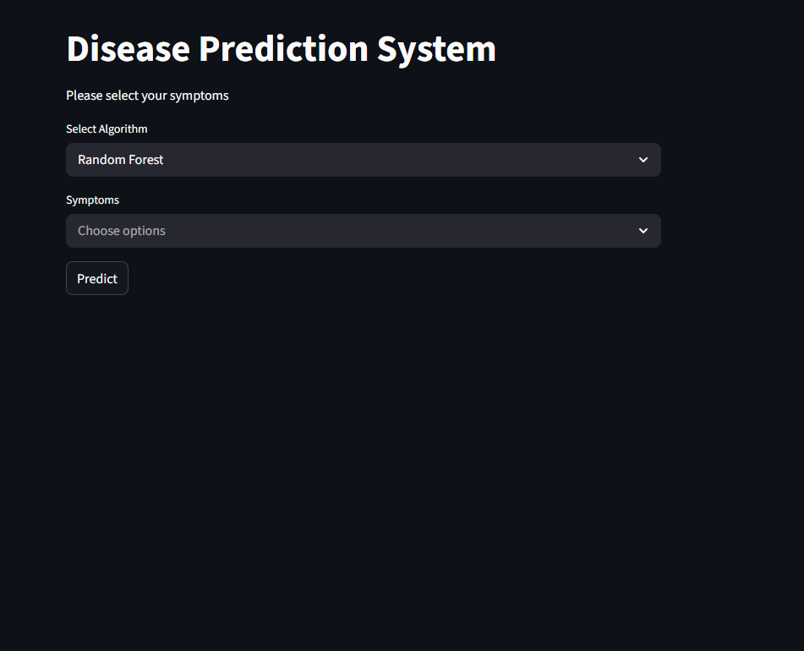
1.2.

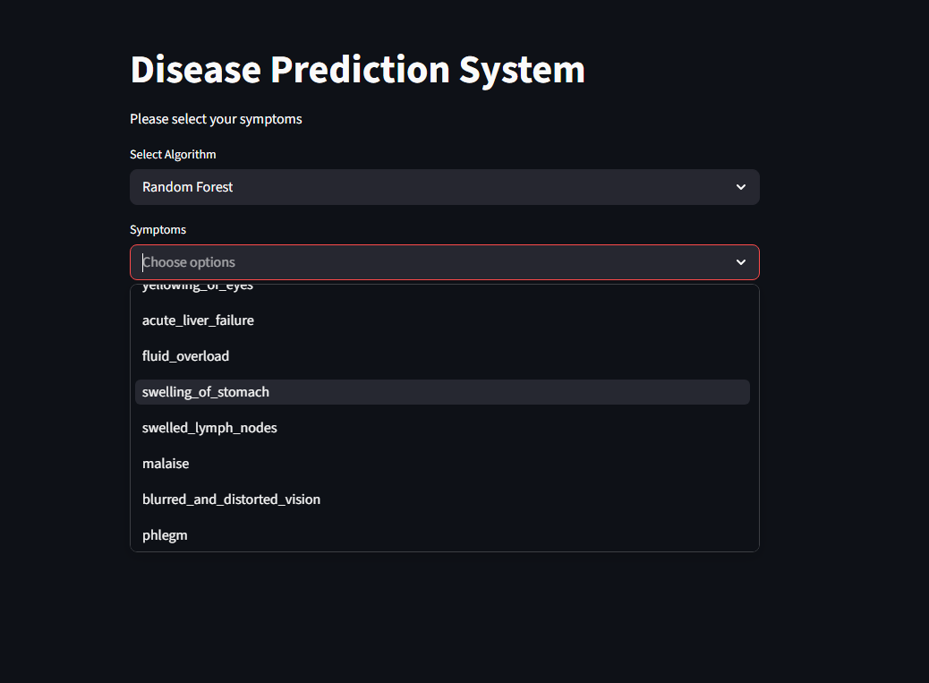
2. After Selecting Algorithm Add Symptoms while there are 133 Symptoms in the system but you can add more select the Symptoms click on predict button.

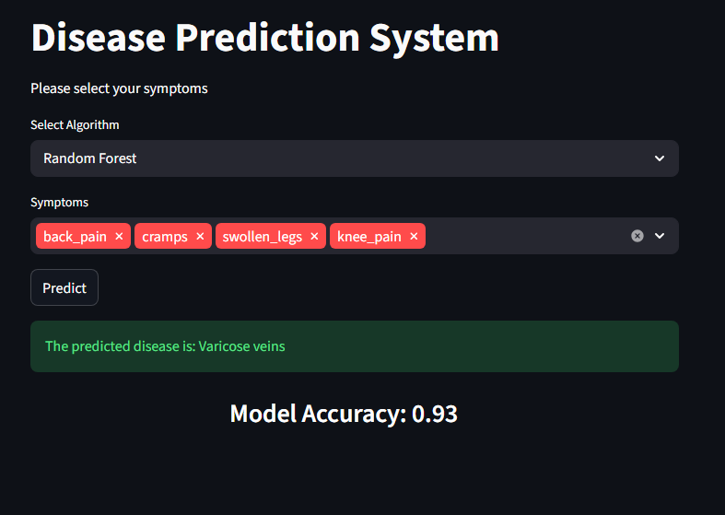
3.now it will predict the Disease based on the selected Symptoms as well as it will show it Accuracy

Please Scan the QR Code For Trying Disease Prediction System


